-- \*\*\*\*\*\*\*\*\*\*\*\*\*\*\*\*\*\*\*\*\*\*\*

-- Name: Wei-Chih Kao

-- ID: 158000190

-- Date: Sep. 17. 2021

-- Purpose: Lab 1 DBS311 NEE

-- \*\*\*\*\*\*\*\*\*\*\*\*\*\*\*\*\*\*\*\*\*\*\*

-- Question 1 –

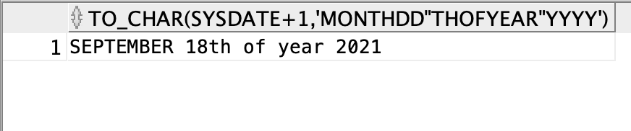

-- Question 2 –

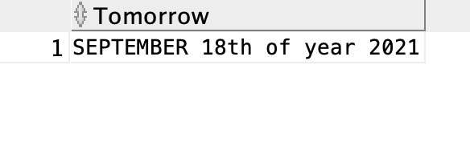

-- Question 3 –

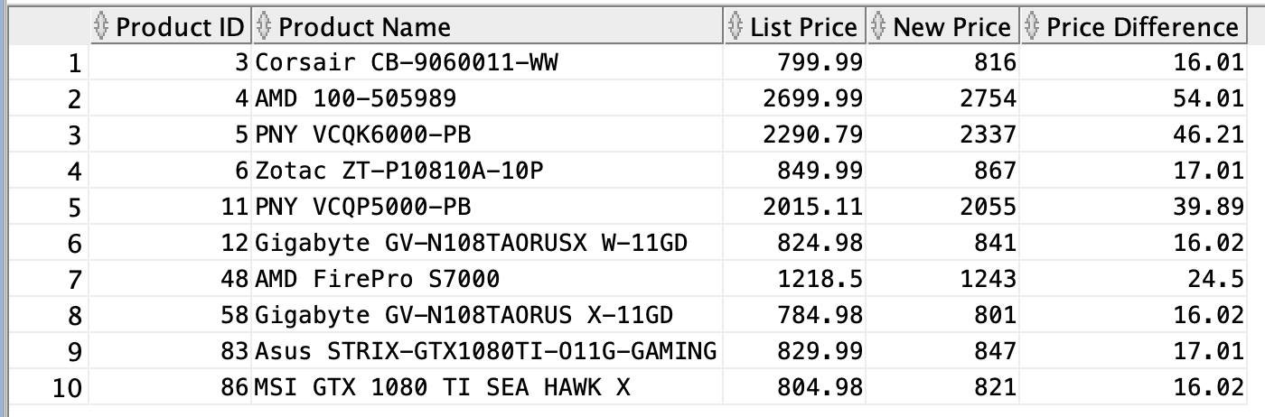

-- Question 4 –

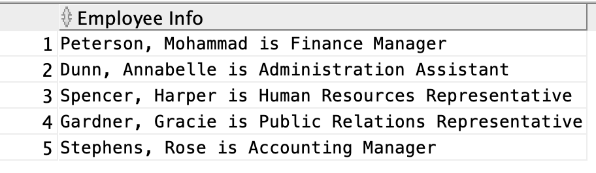

-- Question 5 –

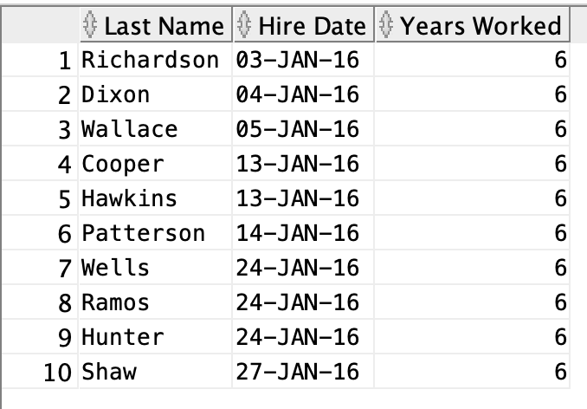

-- Question 6 –

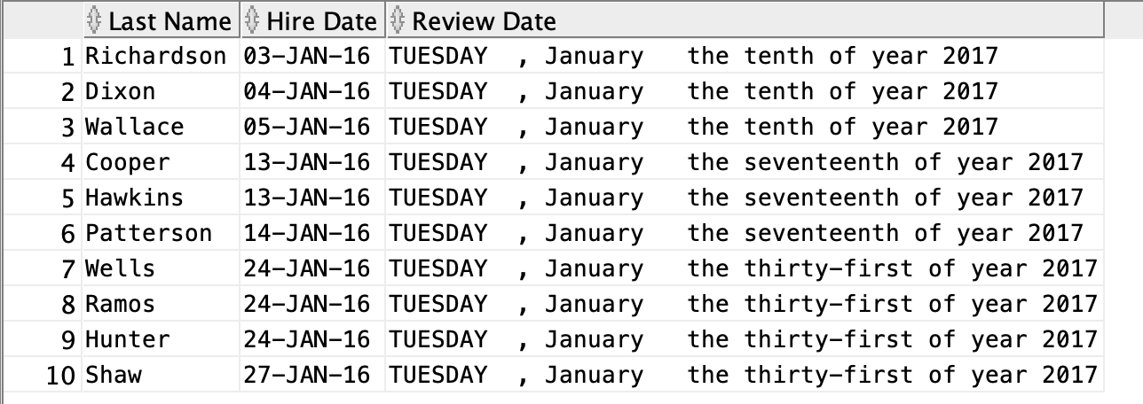

-- Question 7 –

